Symbol Control Task MRI

CURRENT VERSION:
"MRI_ImpSymbControl8s_8blocks.sce"
CURRENT LOCATION:
N:\studies\AllRead\Tasks\MRI_SymbolControl_new-version

Fonts used: AllRead_MRFont1, AllRead_MRFont2, AllRead_MRFont3, Courier Font Chopped
Font size fixation: 30
Font size symbols: 50
Pulse width: 1

Aim
--------------------------------------------------------------------------------------------------------------
Dissociate neural responses to letters (highly familiar, trained and associated with a sound through formal reading instruction), FFlearned (trained for a short duration, associated with a sound), FFfamiliar (trained for a short duration, exclusively visually familiar) and FFnew (entirely new, untrained). In other words, is there a differential response to symbols after even a short training as opposed to no familiarization and if yes, does this shifted response depend on grapheme-phoneme association or visual familiarity alone?
Moreover, is there a difference in results between typical and poor readers?

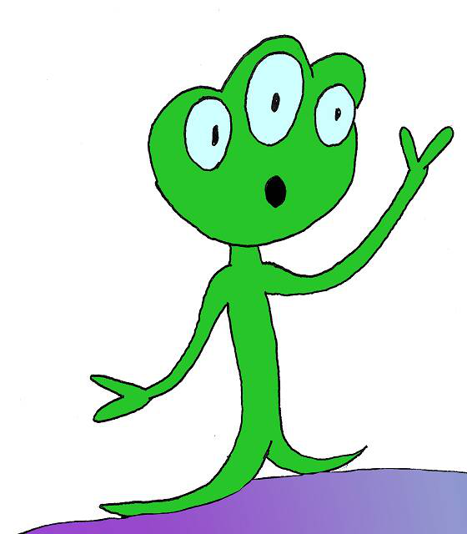
Task design
--------------------------------------------------------------------------------------------------------------
Implicit task. Attention and response to alien figure target appearing on screen in between letters or pseudoletters (0-2 times per block).

Dependent on previously learned items in another fMRI-based task (Feedback Learning Grapheme-Phoneme Association Task; FBLT) and an offline task (OT) – all performed in the same MRI session:

- In the FBLT, children are taught to associate eight (2 blocks x 4 symbols) previously unknown falsefont symbols with familiar (?) sounds (FFlearned; refer to info file of respective task for detailed information).
- Afterwards, children are instructed to trace symbols in a paper-and-pen OT outside of the scanner. Therein, they are visually familiarized with eight additional previously unknown falsefont symbols (FFfamiliar), this time unaccompanied by auditory information.

Structure: 8 Blocks à 4 conditions à 8-10 stimuli
--------------------------------------------------------------------------------------------------------------
Block = one cycle of four conditions, always the same order (Letters, FFlearned, FFfamiliar, FFnew).
Condition = full cycle of 8 trials of one stimulus type + 0, 1, or 2 targets
Stimuli:
Type | Content | Event code
8 x letters | b, m, u, g, t, z, e, p; Font = Courier New Chopped i.e. without serifs | 60
8 x FFlearned | counterbalanced AllRead_MRFont1/2/3 | 70
8 x FFfamiliar | counterbalanced AllRead_MRFont1/2/3 | 80
8 x FFnew | counterbalanced AllRead_MRFont1/2/3 | 90
0-2 x target | occurs zero, one, or two times per condition; mean occurrence number = 1 | Condition event code + 5
Rest

- i.e. mean of 9 trials per block

Timing information
--------------------------------------------------------------------------------------------------------------

 | Duration | Additional info/calculation | Event Code
Stimulus trial | 700 ms | - | See above
Interstimulus interval (ISI) | mean 274 ms | jittered pseudorandomly between 100-500 ms, (same array of 10 ISI-times shuffled for each condition, depends also on target occurrence), but same overall time (sum across 8 ISIs per condition) for each block. | 40
Rest period (between conditions) | mean 6000 ms | pseudorandomly shuffling 3000, 5000, 7000, and 9000 ms per each block | 50
Total | = 8.09 min | 8 blocks x 4 conditions/block x (9 trials/condition x 974 ms/trial + 6000 ms/condition) + 5000 ms MRI_Pulse_wait_beginning + 8000 ms wait_end = 485512‬ ms / 1000/60

Experiment
--------------------------------------------------------------------------------------------------------------

Experiment file asks the user for 3 inputs:
Subject Name/ID: enter subject’s research ID
cbFonts: enter 1, 2, or 3 for counterbalancing of fonts as shown in the table below.

CB |  | FF learned | FF familiar (offline) | FF new
□ 1  □ 2  □ 3 | AllRead-MR font 1  AllRead-MR font 2  AllRead-MR font 3 |  | AllRead-MR font 2  AllRead-MR font 3  AllRead-MR font 1 | AllRead-MR font 3  AllRead-MR font 1  AllRead-MR font 2

backupblocks: there to adapt to interrupted blocks in the FBLT

Scenario in FBTL | enter
B1 and B2 both fine | 0
B1 was interrupted à B3 used instead | 13
B1 and B3 interrupted à B4 used instead of B1 | 14
B2 was interrupted (B1 fine) à B3 used instead | 23
B2 AND B3 interrupted (B1 fine) à B4 used instead | 24
B1 and B2 interrupted and replaced by B3 and B4, respectively | 1234
Abbreviations:
B1…first block of FBLT, B2…second block of FBLT, B3…backup third block, B4…backup fourth block

ATTENTION: For AllRead Study, this entry was done in a different fashion (See file “N:\studies\AllRead\Tasks\MRI_SymbolControl_new-version\Info_backupblocks.docx”) à important to know for data analysis.

Practice trial: Alien shown à child needs to click

Scanning Sequence

………..

Output
--------------------------------------------------------------------------------------------------------------
If same input started a second time, program automatically adds “-2” to the end of the file names.

2 files: one .log and one .txt file as output.
Filename:
subjID-MRI_ImpSymbControl8s_8blocks_cbFont#_B#.log
subjID = subject code (input in popup)
MRI_ImpSymbControl8s = scenario name
condName… see above (input in popup cbFont)
B#... see above (input in popup backupblocks)

subjID-MRI_ImpSymbControl8s_8blocks_cbFont#_B#.txt (content defined in script)

Headers in text file:
trial - trial number (starts counting from 1)
block - block number
stimIndex - stimulus number (in stimulus array, shuffled?)
condition - condition
VstimCaption- prints out name of stimulus
ISIjitter - prints duration of ISI for given trial

Log file:
Subject - Subject ID
Trial - counts all events (i.e. responses and event codes, counts all frames)
Event Type - response or picture (visual stimulus)
Code - event code
Time
Ttime
Uncertainty
Duration
Uncertainty
ReqTime
ReqDur
Stim Type
Pair Index

TRIGGERS
--------------------------------------------------------------------------------------------------------------
Code | Description | Count Total
100 | Welcome pic | 1
200 | End | 1
60 | letters | 8x4x8=256
70 | FFlearned | 8x4x8=256
80 | FFfamiliar | 8x4x8=256
90 | FFnew | 8x4x8=256
Condition event code + 5 | target | 1x4x8= 32

